**Graphene Growth** **Procedure Based on Monte Carlo**

This document is for the fortran procedure of graphene growth. The procedure can simulate the details of graphene growth such as the attachment of the carbon atoms, the edge diffusion of the atoms and the shape of the graphene grains. It can be extended to the more graphene grains growth uniting with the phase field method which is be trying by me. And I hope it can get explain what parameters control the grain shape and how can get large-scale single crystcalline graphene from theory.

**Program flow**

The procedure has tree main steps to simulate the graphene growth. The first is crystal nucleation, in this step, it need nucleation seed. The second is the atoms diffusion arriving at the edge of the grain. Last but not least, the third is the edge diffusion of this arriving atoms. The last two steps is based on probability caculated from the first principle and I make some assumption from other method for example attachment probability of atoms.

1. The first step

Sprinkle seed for graphene.

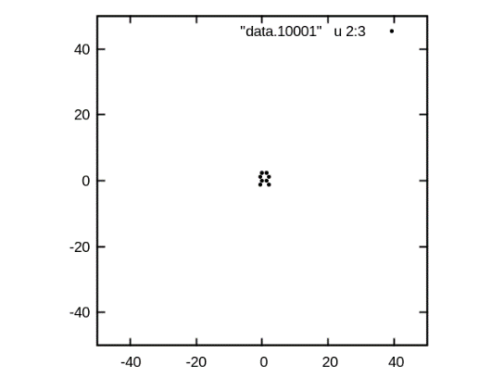

Figure Sprinkle seed for graphene.

1. The second step

Looking for all of the nearest neighbor vacancy of the grains which can attach the atoms.And give every vacancy a probability based anisotropic attachment barrier.

1. The third step

If the vacancy has attached atoms and then the atoms will decide on whether diffuse along the edge. The edge diffusion probability is based on the edge diffusion barrier from the first principle.

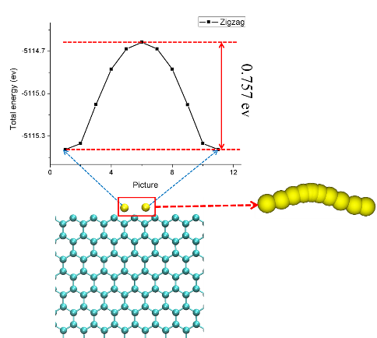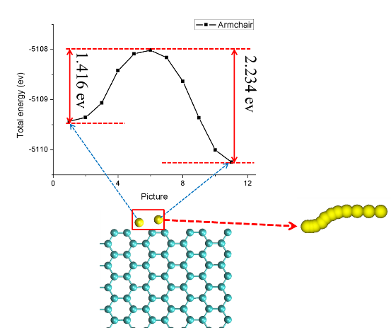

Figure Edge diffusion barrier

The three steps above are one loop of the procedure, and the graphene growth can be simulated one loop after another.